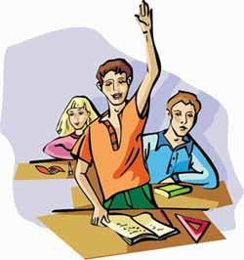
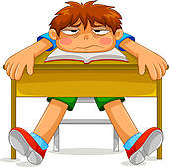
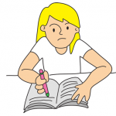
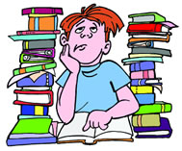
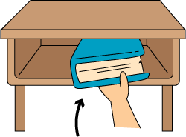
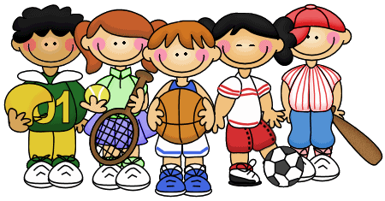
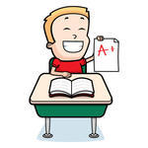
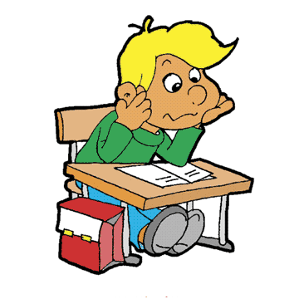
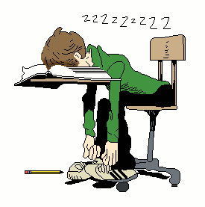
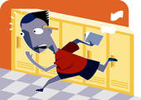
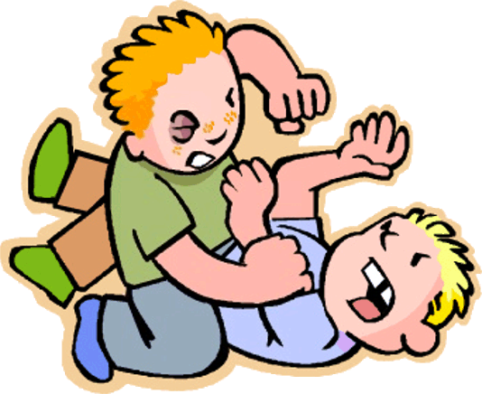
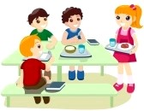
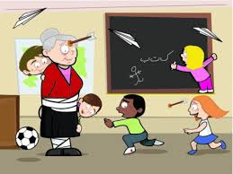
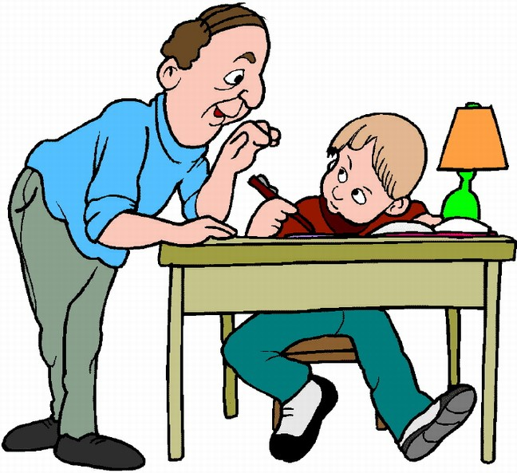
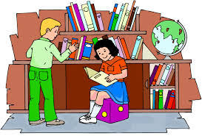
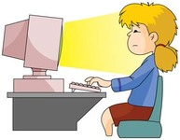
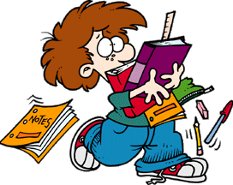
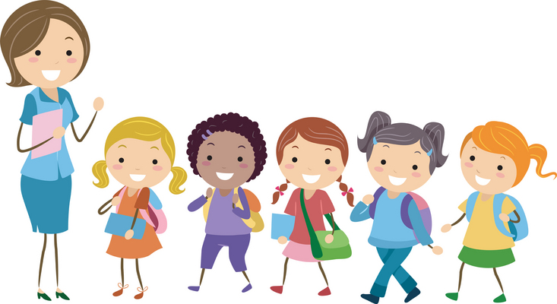
Pupils-----------put their hands up to answer.
You ---------be quiet and --------make too much noise.
Students -----------be lazy, they -------------work!
Sometimes, you -----------write on your copybooks.
Pupils ------------cheat during tests.
You------------listen to the teacher and to your friends.
You -----------look at the board!
You ------------do sports at school and outside school
You -----------try your best to get good marks.
You ------------learn your lessons and be concentrated.
Children ---------read texts to get information
You -------------sleep enough not to be too tired in class
Kids -------------run in the corridors
You------------try to help , for ex. to clean the board
Kids --------------fight during the break.
Many pupils----------have lunch at the canteen.
Kids --------------behave and respect their teacher!!
You-----------often work in groups.
Pupils -----------put their books away after the lessons
You -----------go to the library to borrow books.
Students -------do their homework alone or with some help

You --------------arrive at school late.
You --------------spend too many hours chatting or playing on your computer
You -------------forget your school supplies.
On a trip , you------------listen to what your teacher says
Choose the correct answer.
COMPLETE THE SENTENCES WITH MUST OR MUSTN’T

