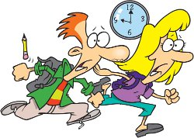
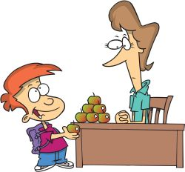
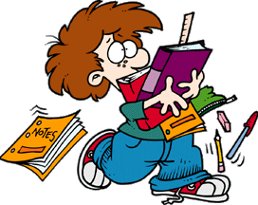
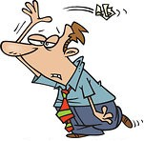
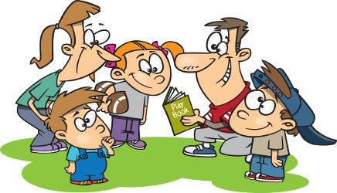
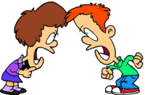
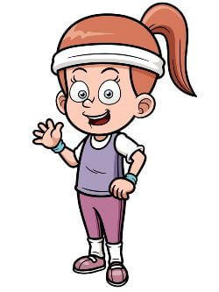
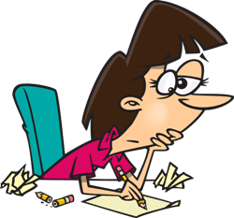

You ---------- raise your hand to answer.
You ---------- learn a foreign language.
You ---------- get bad marks at school.
You ---------- come in time to school.
You ---------- be nice to your teachers.

You ---------- go to the toilet in the break.
You ---------- be nice to your classmates

You ---------- sing songs in your music lesson.

You ---------- be prepared for a test.
You ---------- sleep during the lessons.

You ---------- use your mobile phone at school.
You ---------- bring all your supplies with you.
You ---------- throw paper around.
You ---------- knock before you enter the classroom.
You ---------- play in teams.

You ---------- fight with your classmates.
You ---------- eat and drink during the lessons.
You ---------- chew bubble gum during the lessons.
You ---------- read a lot.

You ---------- get good marks.
You ---------- draw nice pictures in art.
You ---------- wear your sweat suit for PE.
You ----------throw paper planes around.
You ---------- do your homework regularly.
You ---------- do your tasks during lessons.
MUST - MUSTN’T

