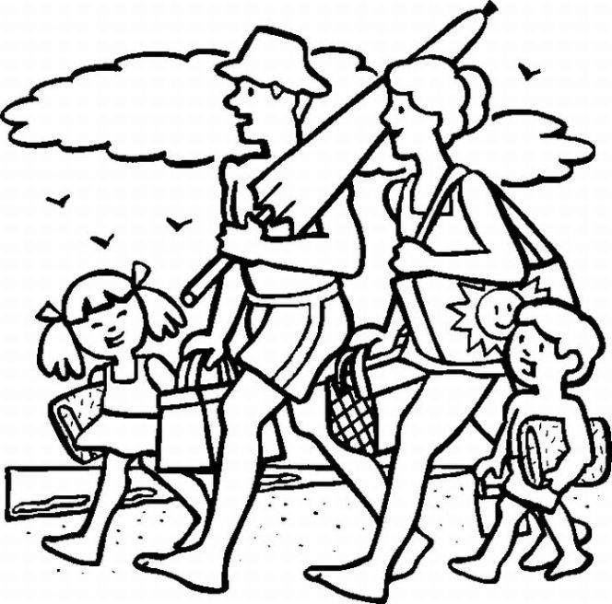
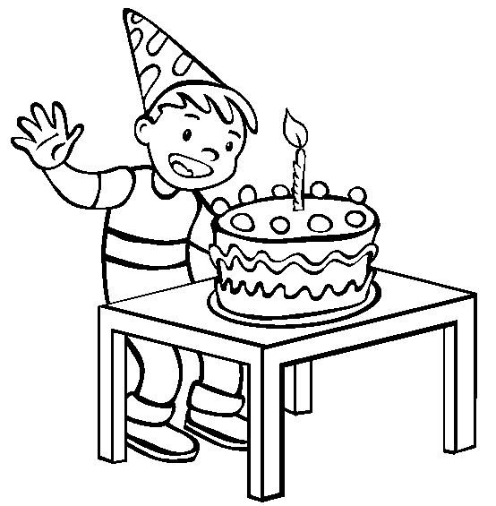
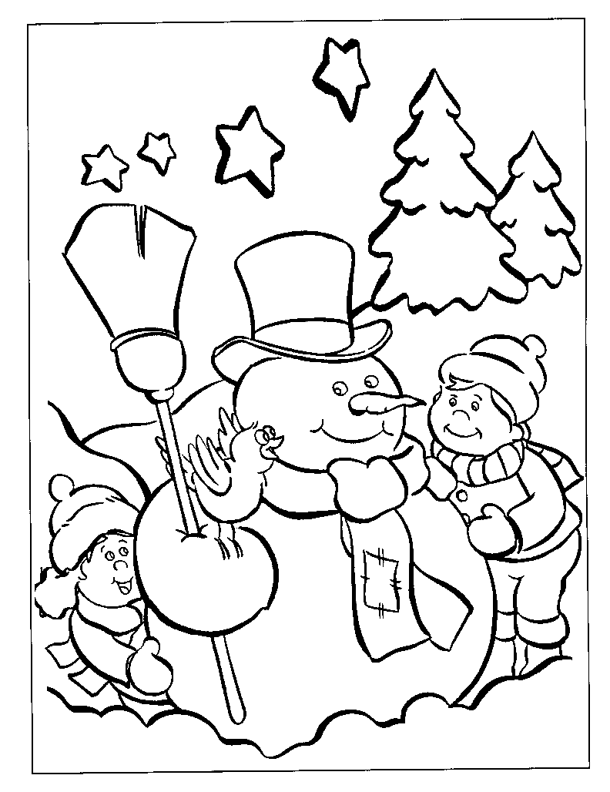
Read, Look, Answer (3): Activities
It’s the boy’s birthday. Yes/no
He is sad. Yes/no
He is wearing a party hat. Yes/no
There are ten candles on the cake. Yes/no
The cake is on a chair. Yes/no
The boy is standing. Yes/no
He is excited. Yes/no
He isn’t wearing any shoes. Yes/no
The candle on the cake is burning. Yes/no
The boy can eat the cake alone. Yes/no

They are going to the mountains. Yes/no
There are five people in this family. Yes/no
Dad is carrying a beach umbrella. Yes/no
Mum is wearing sandals. Yes/no
There aren’t any clouds in the sky. Yes/no
There are birds in the sky. Yes/no
Dad is wearing a baseball cap. Yes/no
They are walking on the beach. Yes/no
The girl has very short hair. Yes/no
The weather is cold. Yes/no
The snowman is holding a broom. Yes/no
There are two trees in the picture. Yes/no
There is a bird on the snowman’s head. Yes/no
What’s the weather like? Warm/freezing
How many children are there? One/two/three
How many stars are there in the sky? Two/four/six
The children are wearing mittens. Yes/no
The snowman isn’t wearing a scarf. Yes/no
The snowman is smiling. Yes/no
The snowman has a long nose. Yes/no

