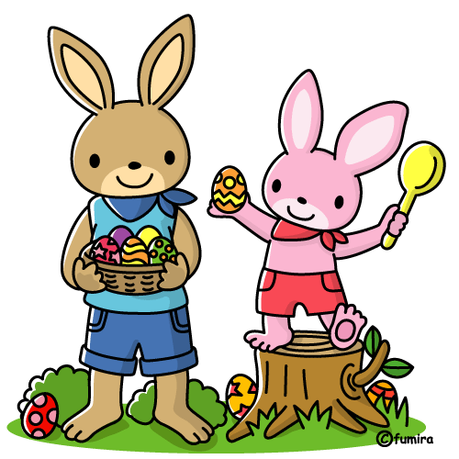

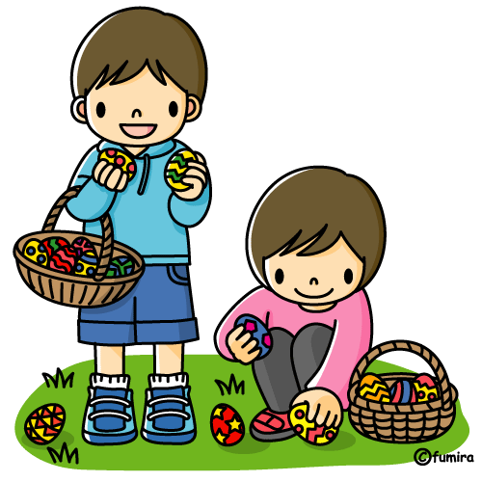


FROM WHOM?WHAT?HOW MANY PLACES?auntcousingrandmamothersisterchocolate bunnychocolate eggchocolate sheepmoneypainted egg23456NAMEAdamAllanDougElliotHughHOW MANY PLACES?2Clue 1: Adam got a chocolate animal from his aunt’s daughter. He visited five places.
Clue 2: The boy who got a chocolate egg visited more places than the boy who got money but less than Elliot.
Clue 3: The grandma gave some money to her grandson. He isn’t Hugh or Doug.3456WHAT?chocolate bunnyClue 4: The boy who is neither Doug nor Elliot was in four places. He got a painted egg but not from his mother.
Clue 5: The chocolate sheep was from an aunt.chocolate eggchocolate sheepmoneypainted egg
Now summarize your answers.
NAMEFROM WHOM?WHAT?HOW MANY PLACES?AdamAllanDougElliotHughNow write sentences. Look at the example.
e.g.: Dave was only in one place. He visited his mother and got a chocolate chicken.
1) ______________________________________________________________________________________
2) ______________________________________________________________________________________
3) ______________________________________________________________________________________
4) _______________________________________________________________________________________
5) _______________________________________________________________________________________
Five boys went to their relatives this Easter. Each boy got different presents from different relatives, and the number of the visited ‘girls’ are different, as well. If you want to know which information belongs to which boy, look at the clues and fill in the tables. Then write full sentences using the solution.
To solve this logic game put an 'X' where there is a relation and '-' where there isn't.
© Susan V Toth
Logic Game – Easter

