Complete the poem using the following words:

we | said |  | nest |  | four |  | sand
bush |  | day |  | tree |  | so

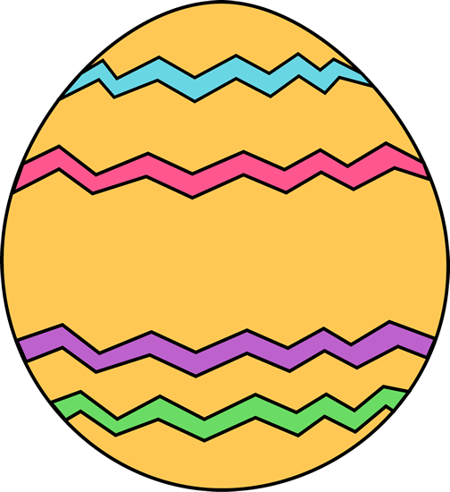
Easter Eggs

Seven little nests of hay
We have made, for Easter _________________
Is tomorrow, and you know
We must have them ready, _________________
When the Rabbit comes she'll see
We expected her, that _________________
Children tried our very best
Each to make the nicest _________________.
One is in the lilac _________________,
Near the ground - last year a thrush
Built a nest there - let me see,
Two are by the apple _________________,
In the clover - that makes three -
One beside the playhouse door,
- Three plus one, that must be _________________-
Two are in the tulip bed -
Was it seven that I _________________?
Oh, yes! six I've counted, and
One is in our pile of _________________.

http://www.chinaflower.com.cn/article/readeaster.asp?id=385

