**around the world**

**EASTER TRADITIONS**



**LUXEMBOURG**

**BERMUDAS**

**GREECE**

**POLAND**

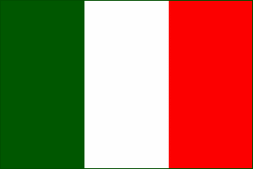

**ROMANIA**

**FINLAND**

**Hauxe, FRANCE**

**Florence, ITALY**

**The day after Easter young boys try to get girls wet with water guns or buckets of water. The tradition says girls who get soaked will marry within the year.**

**People have**

**“egg battles” –they knock two hard-boiled eggs. The egg which shell doesn’t break – wins and the loser has to eat all the boiled eggs the winner breaks.**

**On Easter Monday people make a giant omelet and serve it in the town’s main square. It can feed up to 1000 people.**

**In the morning of**

**Holy Saturday people have a tradition to throw clay pots with water out of their windows. This symbolizes the coming of spring and new harvest season.**







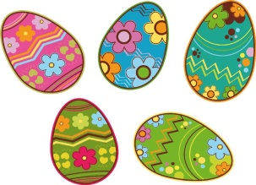

**On Easter kids dress up in witch costumes and walk in the streets asking for treats.**

**People organize a parade through the town during which they explode a big cart. They believe it’s for a good harvest.**

**Guys give the girl**

**they like a pretzel on said Sunday. If she accepts the treat, the guy is allowed to visit the girl on Easter Sunday and will get an egg in return.**

**On Easter people make their own kites with wooden sticks, colorful paper and a special “hummer” on the top. They then gather and fly them in the sky.**

