Easter Island

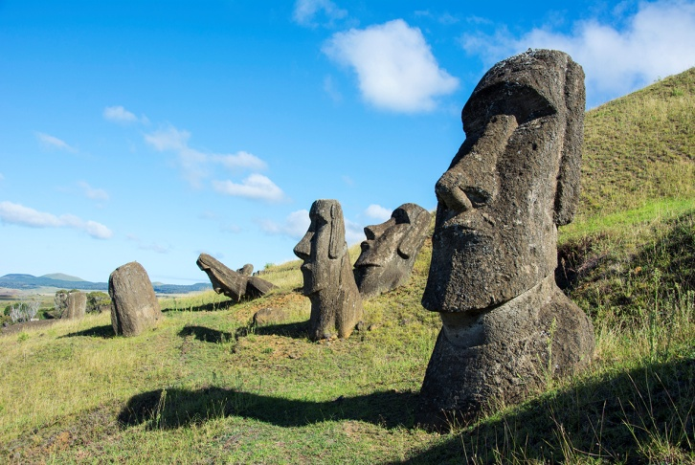
Easter Island is a small triangle of rock situated in the Pacific Ocean. It’s about 2,000 miles (1)…………. the nearest city. Easter Island is (2)…………. for its statues. Hundreds of these huge stone faces can be (3)……….. all over the island. Who made them? How (4)…………. they move these giant pieces of rock? What happened (5)………… the people who lived there? Studies show that people (6)………….. arrived on the island about 1600 years ago. They had a very advanced culture. They made many objects and they had their (7)………… written language. However, the number of people in the island grew and grew (8)…………. it reached about 10,000 people. Soon there were too many people and there wasn’t (9)…………… food to eat. A terrible war started and (10)…………… of the statues were broken. When western explorers (11)………….. the island on Easter Day in 1722, the huge rock statues were the only (12)…………. that a great society had once lived there.

1. | a) for | b) from | c) on | d) by
2. | a) important | b) interesting | c) famous | d) fascinating
3. | a) looked | b) located | c) found | d) situated
4. | a) have | b) were | c) had | d) did
5. | a) to | b) with | c) about | d) for
6. | a) once | b) first | c) just | d) already
7. | a) only | b) own | c) clever | d) self
8. | a) so | b) until | c) although | d) because
9. | a) many | b) some | c) too | d) enough
10. | a) many | b) few | c) lot | d) enough
11. | a) invented | b) discovered | c) sailed | d) came
12. | a) symbol | b) signal | c) sign | d) mark

