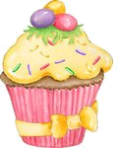
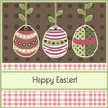
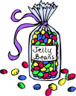
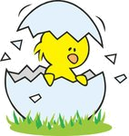

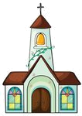
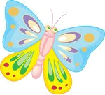
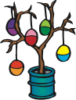
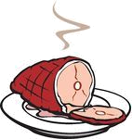
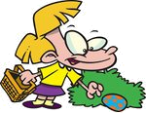
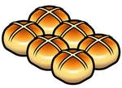
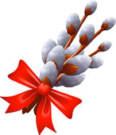
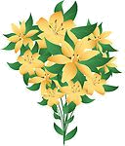


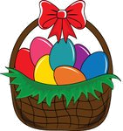
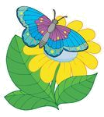
EASTER TIME
Find twelve Easter words in the word search.

JALBNRUMIBEGGHUNTINGLABONNETORLCARDRNNCAYHSLILYYHSBICATEIOUSECVMPGFTRAAKCBLGEGCUNNJIOSPDHASIGREETING
Put the letters in the correct order.

1 lraip: _________________
2 eirtggen:_________________
3 utomces:_________________
4 ntoebn:_________________
5 citnak:_________________
6 agsrs:_________________
7 nooeirctda:_________________
8 hccrhu:_________________
9 taarcseeek:_________________
10 ghgtneuing:_________________
Match the words and the pictures.
1 Easter card 2 egg hunting 3 church 4 catkin 5 hot cross buns
6 Easter cupcake 7 ham 8 jelly beans 9 spring 10 roasted lamb
11 greeting 12 chick 13 butterfly 14 lily 15 egg tree
Find the odd one out.

1 bunny – lamb – reindeer - chick
2 butterfly – bunny – ladybug - bee
3 egg – sprout – catkin - tree
4 egg hunting – egg painting – egg rolling – egg eating
5 ham – egg – turkey - lamb
6 tulip – ladybug – daffodil - lily

Find the Easter words in the circle.
eggpaintingdaffodilgoodfridayeastersundayspringhotcrossbunholybiblesproutroastedlambeastercakedecorationchocolateeggbeecatkinbow
What are they?

1 A small round cake or piece of bread: ________________
2 A Sunday in March or April, and the days around it, when Christians think about coming back to life: ______________
3 The part of the year after winter when plants start to grow: _________________
4 The Friday before Easter when Christians remember the death of Christ: __________________
5 Meat from a pig’s leg that you can keep for a long time because salt or smoke was used to prepare it: ___________

spring ham Easter bun Good Friday

