A BUSY EASTER BUNNY
A rebus story: read and then rewrite the test with the missing words and color.the eggs.

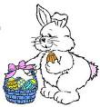

The Easter is very busy today. He wants to paint the eggs for the of the world. The goes to the market and buys some . He its eggs

with fantastic colors: a red , a yellow , a pink , an orange ,
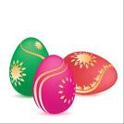
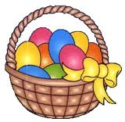
a green . Then he puts its colored in a.

The Easter is very happy now. He starts hiding its in the
into the and in the bushes. On Easter Day all the are very happy, because

they can find many, many during their Easter egg

TRUE OR FALSE?
 | TRUE | FALSE
1) THE EASTER BUNNY IS VERY BUSY
2) THE EASTER BUNNY GOES TO THE MARKET
3) THE EASTER EGGS ARE YELLOW
4) THE EASTER BUNNY IS HAPPY

