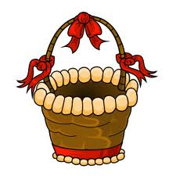
Read the story below and answer the questions.

An Easter Story

Joshua Smith loves Easter. He loves painting eggs with his favourite colours, making Easter baskets, playing Easter games with his cousins and having Easter egg hunts in the garden. However, his little sister Mary doesn't like Easter. She doesn't like it because she never finds any Easter eggs when they have an Easter egg hunt.
This year, Joshua gets to hide the Easter eggs for the Easter egg hunt. He hides some eggs in Mary's favourite places - the flower garden and the doghouse. He also puts a special pink and blue egg in her bicycle basket because he really wants her to find an Easter eggs. He really wants her to have fun this Easter.

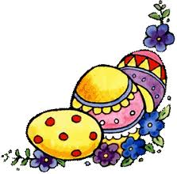
True or False:

1. Joshua doesn't like Easter.
2. Joshua plays Easter games with his friends.
3. He decorates Easter eggs using his favourite colors.
4.. His sister's surname is Mary.
5. Joshua put some eggs in the tree house.
6. His sister dislikes Easter.
7. She always finds Easter eggs when they have an Easter egg hunt.
8. Joshua put a pink and blue egg in the Easter basket.

Answer the questions.

- Does Joshua like Easter?
- What activities does Joshua do at Easter?
- Where does Joshua put the Easter eggs?
- Why does Mary dislike Easter?
- Why does Joshua hide the eggs in Mary's favourite places?

