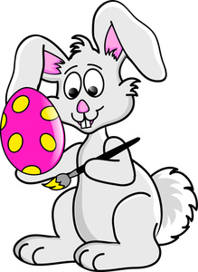
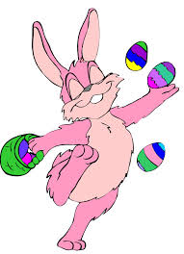
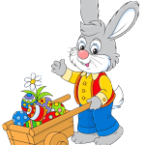
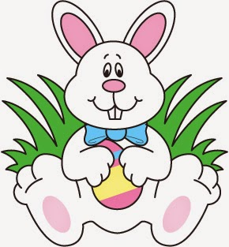
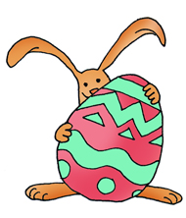
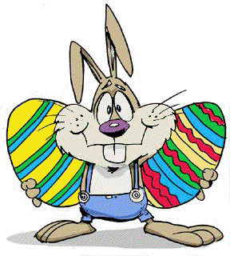
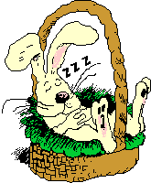
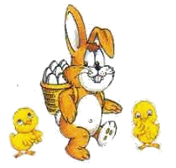
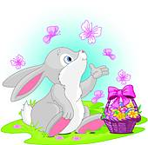
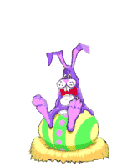
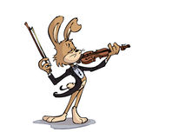
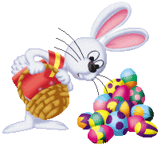
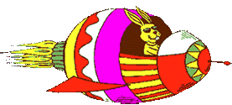
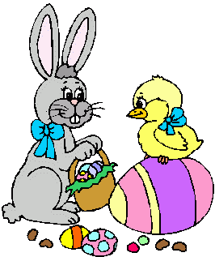
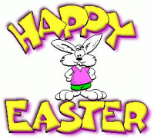
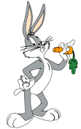
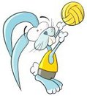
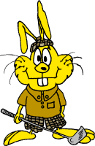
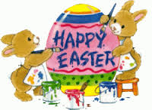
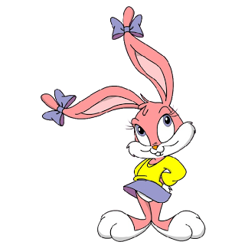
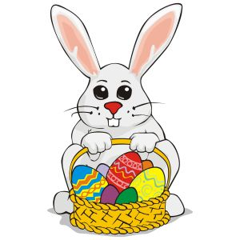
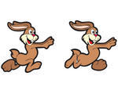
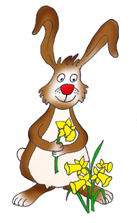
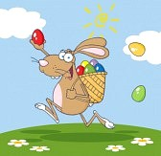
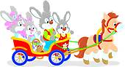
Bunny (paint)-----------------------his ------- pink.
Bunny ( juggle) ---------------- with just one paw!
Bunny (push)---------------a wheelbarrow full of------------.
Bunny( sit) ---------------------in front of a bush.
Bunny (hide) -------------------behind a big egg!
Bunny ( carry)-------------------two big eggs.
Bunny ( play)----------------------the-----------
Bunny (look) -----------------for his keys among the eggs
Bunny (fly) -----------------------in a space shuttle.
Bunny (sleep) --------------------in his ----------.
Bunny ( chat)--------------------with his friend Chicky
Bunny (wish) ------------------------us a Happy Easter.
Bunny (eat) ----------------------a ----------------.
Bunny ( walk) --------------------with his two friends ,the chicks
Bunny ( play) -------------------------volleyball.
Bunny ( play) -----------------------golf.
The bunnies (write) -----------------Happy Easter.
Bunny (try) --------------------to catch a butterfly.
Bunny (sit) ------------------------on top of his egg.
Bunny (count) -----------------------his -----------.
Miss Bunny (pose) -------------------for the new Easter card
The bunnies (run)-------------- to get their eggs.
Bunny (pick) ------------------------flowers.
Bunny (throw ) ---------------- eggs in the park.
The bunnies (have)---------------a ride in a horse cart.
Choose the correct answer.
Make correct sentences using the present continuous of the verbs, and complete with the missing words for some pictures .

