- What is the Easter Bunny's favorite music? | ___ | Hop suey.
- What is the Easter Bunny's favourite sport? | ___ | They lived hoppily ever after.
- What would you get if you crossed the Easter Bunny with a famous French general? | ___ | Eggs-hausted..
- How did the Easter Bunny dry himself after getting wet? | ___ | 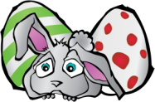  An egg-splanation!
- Why was the Easter Bunny so upset? | ___ | Basket-ball.
- How does the Easter Bunny travel? | ___ | He was an egg-stra.
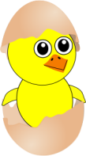  - How should you send a letter to the Easter Bunny? | ___ | Napoleon Bunnyparte!
- How does the Easter Bunny stay in shape? | ___ | He said it was eggs-cellent!
- What does the Easter Bunny order at the Chinese restaurant? | ___ | 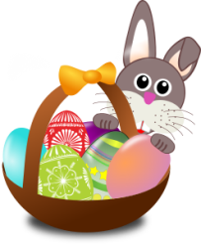  Those with a “hoppy” ending.
- How does the Easter Bunny feel after Easter? | ___ | Hip-hop.
- What happened to the Easter Bunny when he misbehaved at school? | ___ | Fry-day
- What did the Easter Bunny say about the Easter parade? | ___ | With a hare dryer…
- What part did the Easter Bunny play in a movie? | ___ | They don't want to get "beat up"
- What kind of movies does the Easter Bunny like? | ___ | You're "Egg-stra special"!
- What happened when the Easter Bunny met the rabbit of his dreams? | ___ | By hare-plane!
- What did the mommy egg say to the baby egg on Easter? | ___ | By hare mail!
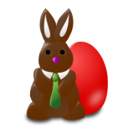  - What do you need if your chocolate eggs mysteriously disappear? | ___ | He does lots of eggs-ercise and  hare-obics.
- What day does an Easter egg hate the most? | ___ | He was eggs-pelled!
- Why don't Easter eggs go out at night? | ___ | He was having a bad hare day.

A. What is the difference between “hare” and “hair”? How do you pronounce these words?
B. How do you pronounce the following words: exercise, explanation, exhausted?
C. Match the questions and the answers to complete the Easter jokes. Have fun!
